Idris Ratlamwala

C31 - 2003145

Experiment 7: Programs on Array of Objects

**Theory :**

**Array of objects :**

Java is an object-oriented programming language. Most of the work done with the help of **objects**. We know that an array is a collection of the same data type that dynamically creates objects and can have elements of primitive types. Java allows us to store objects in an array. In Java, the class is also a user-defined data type. An array that conations **class type elements** are known as an **array of objects**. It stores the reference variable of the object.

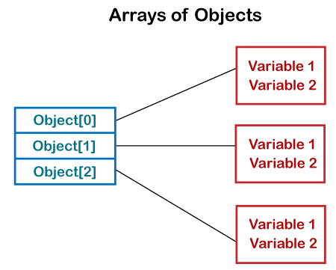

**Creating an Array of Objects**

Before creating an array of objects, we must create an instance of the class by using the new keyword. We can use any of the following statements to create an array of objects.

**Syntax:**

1. ClassName obj[] = new ClassName[array_length];

Or

2. ClassName[] objArray;

Or

3. ClassName objeArray[];

Suppose, we have created a class named Employee. We want to keep records of 20 employees of a company having three departments. In this case, we will not create 20 separate variables. Instead of this, we will create an array of objects, as follows.

1. Employee department1[20];
2. Employee department2[20];
3. Employee department3[20];

The above statements create an array of objects with 20 elements.

**Initializing the array Of Objects**

Once the array of objects is instantiated, we have to initialize it with values. As the array of objects is different from an array of primitive types, we cannot initialize the array in the way we do with primitive types.

In the case of an array of objects, each element of array i.e. an object needs to be initialized. One way to initialize the array of objects is by using the constructors. When we create actual objects, we can assign initial values to each of the objects by using for loop. We can also have a separate member method in a class that will assign data to the objects.

Eg.

for(int i=0 ; i<20 ; i++) department1 [i]=new Employee ();

**A.**

**Aim :**

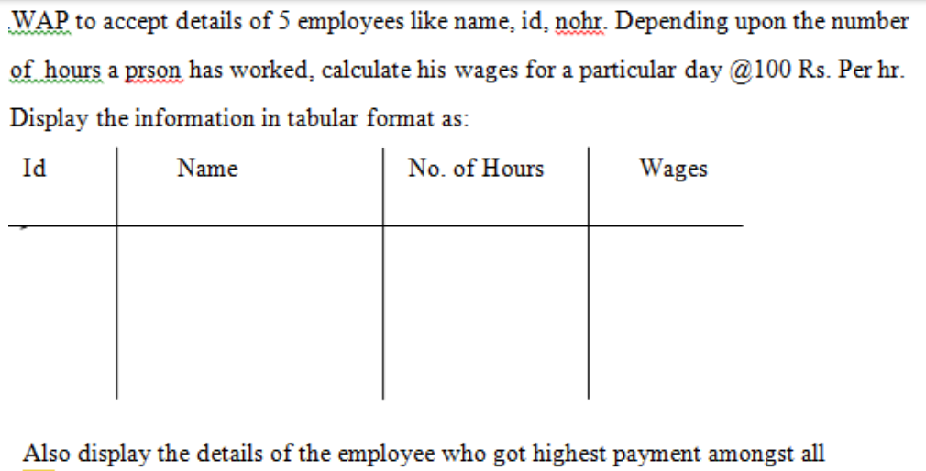

**Program :**

import java.util.Scanner;

class Emp{

    int id,hours,wages;

    String name;

}

public class Employee {

    public static void main(String[] args) {

        Scanner sc = new Scanner(System.in);

        int n=5,maxWage=0;

        Emp[] e = new Emp[n];

        for(int i=0;i<n;i++){

            e[i]=new Emp();

            System.out.print("\nEnter name : ");

            e[i].name=sc.next();

            System.out.print("Enter ID : ");

            e[i].id=sc.nextInt();

            System.out.print("Enter no. of hours : ");

            e[i].hours=sc.nextInt();

        }

        System.out.println("\nId\t| Name\t| Hours\t| Wages\n-------|------|------|------");

        for(int i=0;i<n;i++){

            e[i].wages=e[i].hours*100;

            System.out.println(e[i].id+"\t| "+e[i].name+"\t| "+e[i].hours+"\t| "+e[i].wages);

            maxWage=(e[i].wages>e[maxWage].wages) ? i : maxWage;

        }

        System.out.println("\nDetails of employee with highest wage");

        System.out.println("Name : "+e[maxWage].name+"\nId : "+e[maxWage].id+"\nNo of hours : "+e[maxWage].hours+"\nWage : "+e[maxWage].wages);

    }

}

**Output :**

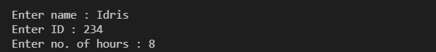

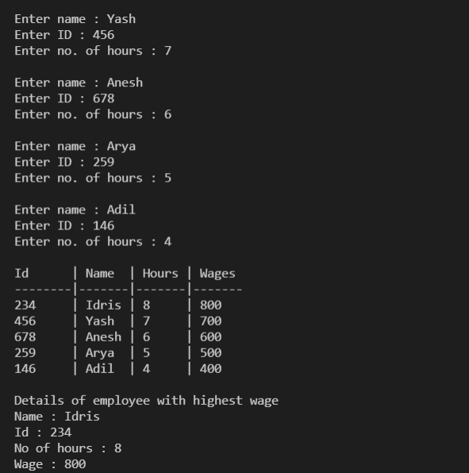

**B.**

**Aim :** For Annual Examination results of 5 students, taking into consideration

marks obtained in three subjects, WAP to determine

i . Determine Total marks obtained by each student

ii. The student who obtained highest total marks.

**Program :**

    import java.util.Scanner;

    class Student{

        int phy,chem,math,total;

        Scanner sc = new Scanner(System.in);

        Student(int i){

            System.out.println("Student "+(i+1)+" enter your marks in ");

            System.out.print("physics : ");

            phy=sc.nextInt();

            System.out.print("Chemistry : ");

            chem=sc.nextInt();

            System.out.print("Maths : ");

            math=sc.nextInt();

            total= phy+chem+math;

        }

    }

    public class AnnualExamination {

        public static void main(String[] args) {

            int n=5,max=0;

            Student[] s = new Student[n];

            for(int i=0;i<n;i++) s[i] =new Student(i);

            System.out.println("\nStudent\tPhy\tChem\tMath\tTotal\n---------------------------------------");

            for(int i=0;i<n;i++){

                System.out.println((i+1)+"\t"+s[i].phy+"\t"+s[i].chem+"\t"+s[i].math+"\t"+s[i].total);

                max = (s[i].total>s[max].total) ? i : max;

            }

            System.out.println("\nHighest marks("+s[max].total+") are scored by student "+(max+1)+".");

        }

    }

**Output** :

